TALARIA ANALYTICS

Excursion Dashboard
Design Specification

Layout · Sections · Data Requirements · Visual Specs · Interactions

Purpose of This Document
This is a DESIGN REFERENCE for building the excursion analytics dashboard in the Talaria platform. It describes every section of the dashboard, what data feeds into it, how each visualization should look and behave, and what filters/interactions are needed. Use this alongside the Development Milestones document to build the UI.

1. Dashboard Overview
The excursion dashboard is a two-page analytics view that reads all archived trades from a session and displays aggregate statistics, distributions, and optimization tools. It is the primary analysis interface for the trader after completing a backtesting session.

1.1 Page Layout
Page 1: Session Overview + Excursion Core
Top bar: Filters (pair selector, win/loss filter, setup filter, gross/net toggle)
Row 1: Session performance stat cards (7 cards)
Row 2: Equity curve (full width)
Row 3: Per-instrument breakdown table
Row 4: Excursion stat cards (7 cards)
Row 5: Three charts side by side — What-If bars, Capture Ratio, Post-Exit MFE Curve
Row 6: Three charts side by side — MAE Distribution, MFE Distribution, During vs Total Scatter
Row 7: Planned vs Actual stats + Advanced Management stats

Page 2: Deep Analysis + Optimization
Row 1: Setup comparison (full width grouped bar chart)
Row 2: Trade path cloud (wide) + Post-exit MFE by setup (narrow)
Row 3: Box plots at key moments (wide) + Losers recovery rate (narrow)
Row 4: What-If simulator section — Expectancy heatmap + Simulated equity curve
Row 5: Interactive TP/SL optimizer (excursion bars with movable lines)

1.2 Global Filters
These filters sit at the top of the dashboard and affect ALL charts and stat cards simultaneously when changed.
Filter | Options | Default | Effect
Pair | All Pairs / EURUSD / GBPUSD / etc. | All Pairs | Shows only trades for the selected pair
Result | All / Winners / Losers | All | Filters by trade outcome
Setup | All / FVG / OB / Breaker / MSS / IFVG | All | Filters by setup tag
Gross / Net | Toggle switch | Net | Switches all RR, PnL, and efficiency values between before and after costs
Session Warning | Include / Exclude | Include | Excludes trades with post-exit session boundary crossover from post-exit analytics

1.3 Raw Data Required
Three Things Feed the Entire Dashboard
1. TRADE OBJECT: All scalar fields (entry, exit, RR, MFE/MAE, costs, setup, pair, etc.). See Milestone 5 schema.
2. THREE ARRAYS PER TRADE: bar_close_r[], bar_high_r[], bar_low_r[] — from entry through 50 bars post-exit. All in R-multiples from first entry price.
3. SESSION OBJECT: Starting balance, leverage, equity_curve[], per-instrument settings.
Every chart is computed from these. No additional data collection is needed.

2. Session Performance Section
2.1 Stat Cards
Seven cards in a horizontal row. Each card shows: a label (small, gray), a large value (colored), and a subtitle (small, gray).
Card | Value | Color | Data Source
BALANCE | Current session balance, formatted as currency | Green if > start, red if < start | session.current_balance
NET PnL | Balance minus starting balance, with + sign | Green if positive, red if negative | Calculated
WIN RATE | Winners divided by total trades, as % | Gold | Count from trades
PROFIT FACTOR | Sum of winning dollars divided by abs sum of losing dollars | Green if > 1, red if < 1 | Calculated from pnl_dollars_net
EXPECTANCY | Average actual_rr_net across all trades, in R | Green if positive | Mean of actual_rr_net
MAX DD | Largest peak-to-trough equity drop, in dollars | Red always | session.max_drawdown_dollars
COMMISSION | Total commission paid across all trades | Orange | Sum of commission_total

2.2 Equity Curve
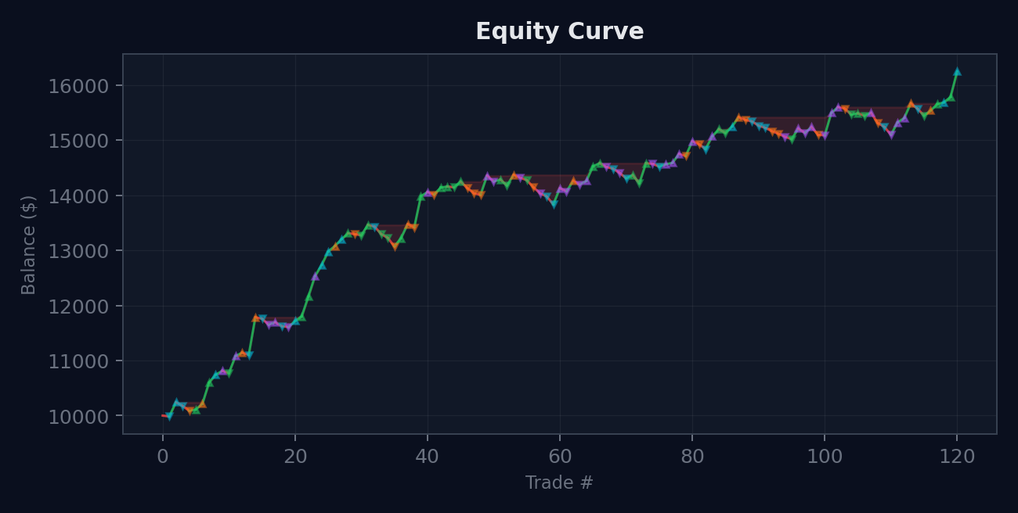
Equity curve: balance after each trade, color-coded by gain/loss, with drawdown zones shaded.
Property | Specification
Chart type | Line chart, one point per trade closure
X-axis | Trade number (1, 2, 3...)
Y-axis | Account balance in dollars
Line color | Green for rising segments, red for falling segments
Drawdown shading | Red fill between the equity line and the running peak line
Trade markers | Small dots colored by pair (EURUSD = cyan, GBPUSD = green, etc.)
Data source | session.equity_curve[] array
Interaction | Hover on a dot shows: trade #, pair, RR, PnL, balance after

2.3 Per-Instrument Breakdown Table
A table with one row per pair and a totals row at the bottom.
Column | Data Source
Pair | Ticker name, colored with the pair’s accent color
Trades | Count of trades for this pair
Win Rate | Winners / total for this pair, as %
Net PnL ($) | Sum of pnl_dollars_net for this pair
Avg RR | Mean of actual_rr_net for this pair
Avg MAE | Mean of mae_r for this pair
Avg MFE | Mean of mfe_r for this pair
Capture % | Mean of capture_ratio for winners of this pair
Comm ($) | Sum of commission_total for this pair

3. Excursion Overview Section
3.1 Excursion Stat Cards
Seven cards, same layout as session cards.
Card | Formula | Color
AVG MAE | Mean of mae_r across filtered trades | Red
AVG MFE | Mean of mfe_r across filtered trades | Green
CAPTURE | Mean of capture_ratio for winners (0–100 range) | Gold
WIN MAE 90th | 90th percentile of mae_r for winners only | Gold
MGMT GAP | Mean(mfe_r for wins) − mean(actual_rr_gross for wins) | Red
EXIT GAP | Mean(total_mfe_r for wins) − mean(mfe_r for wins) | Orange
RECOVERY | Count(losers where would_have_won) / count(losers) × 100 | Cyan

3.2 “What If” Bars
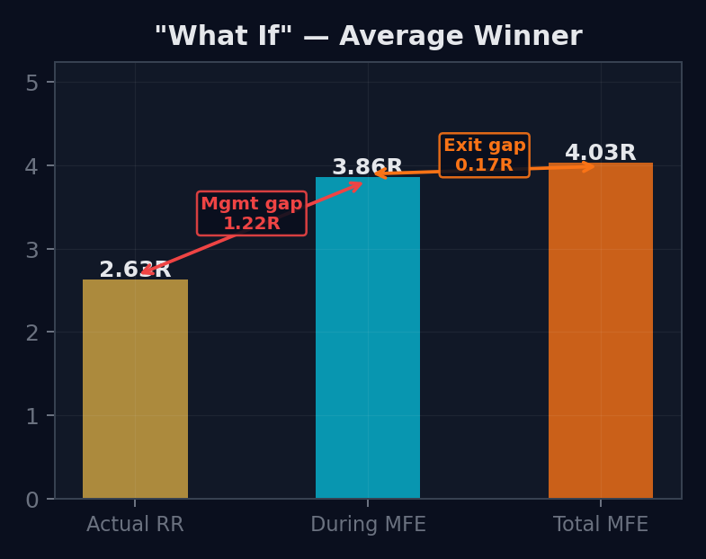
Three bars showing what you got vs what was available, with gap annotations.
Property | Specification
Chart type | Vertical bar chart, 3 bars
Bar 1 (gold) | Average actual_rr for winners — “What You Got”
Bar 2 (cyan) | Average mfe_r for winners — “Available During Trade”
Bar 3 (orange) | Average total_mfe_r for winners — “Available Total”
Red arrow | Between bar 1 and 2, labeled with management_gap value
Orange arrow | Between bar 2 and 3, labeled with exit_timing_gap value
Interaction | Toggle gross/net affects bar 1 value

3.3 Capture Ratio Histogram
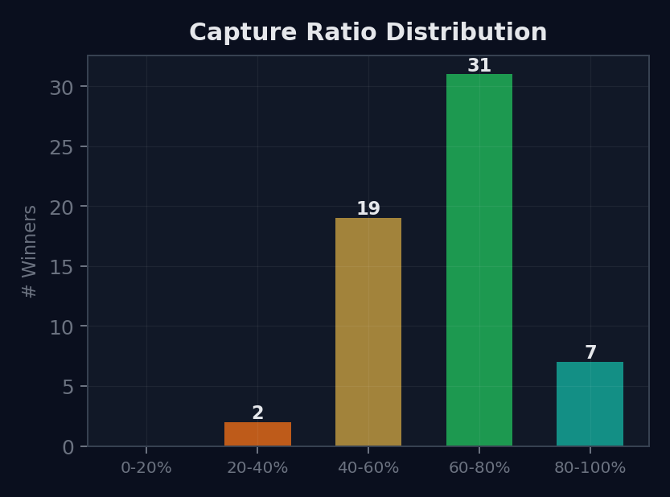
Distribution of capture efficiency across winners, color-coded by performance.
Property | Specification
Chart type | Vertical bar chart, 5 buckets
Buckets | 0–20%, 20–40%, 40–60%, 60–80%, 80–100%
Colors | Red, orange, gold, green, teal (worst to best)
Y-axis | Count of winning trades in each bucket
Data | capture_ratio for each winner: actual_rr_net / total_mfe_r × 100
Bar labels | Count number on top of each bar

3.4 Post-Exit MFE Curve
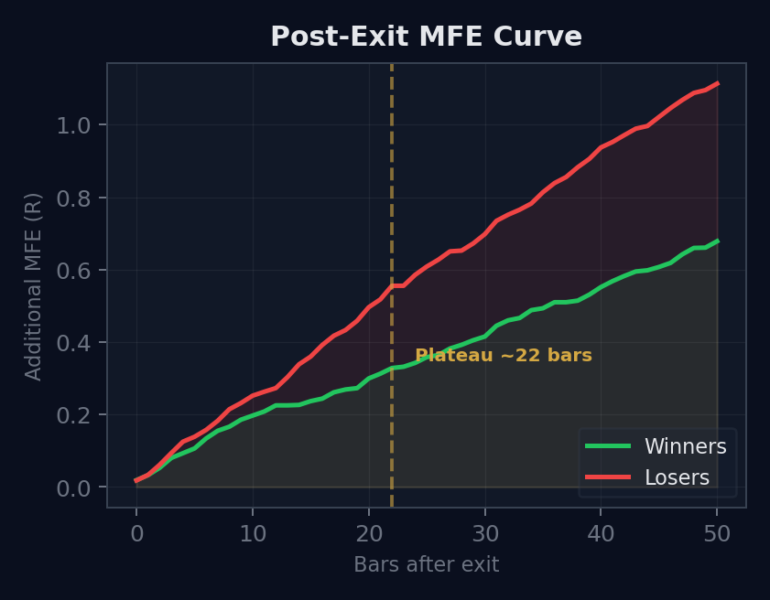
How much more the market moved after exit, with the plateau point marked.
Property | Specification
Chart type | Line chart, 2 lines (winners green, losers red)
X-axis | Bars after exit (0 to 50)
Y-axis | Average additional MFE in R (measured from exit price)
Calculation | At each bar N: for each trade, max favorable R in post_path from exit to bar N. Average across all trades.
Plateau line | Dashed gold vertical line where curve slope drops below 25% of average slope
Fill | Semi-transparent fill under each line

4. Distribution Charts
4.1 MAE Distribution
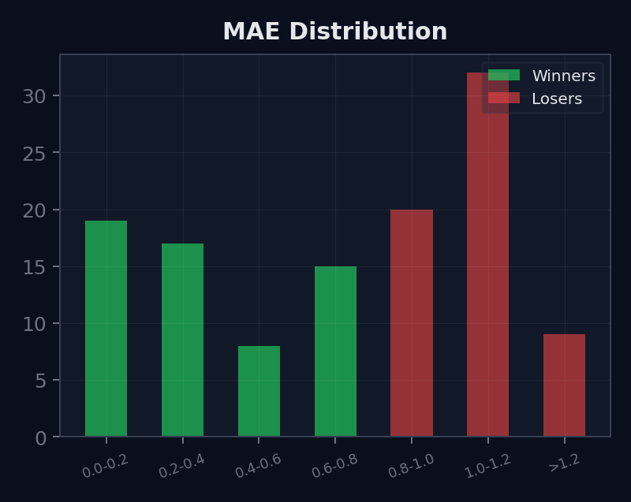
How deep trades go against you. Stacked winners (green) vs losers (red).
Property | Specification
Chart type | Stacked bar chart
Buckets | 0–0.2R, 0.2–0.4R, 0.4–0.6R, 0.6–0.8R, 0.8–1.0R, 1.0–1.2R, >1.2R
Green (bottom) | Count of winners in each bucket
Red (top) | Count of losers in each bucket
Data | mae_r for each trade
Key insight | The bucket where green bars stop = optimal SL boundary

4.2 MFE Distribution
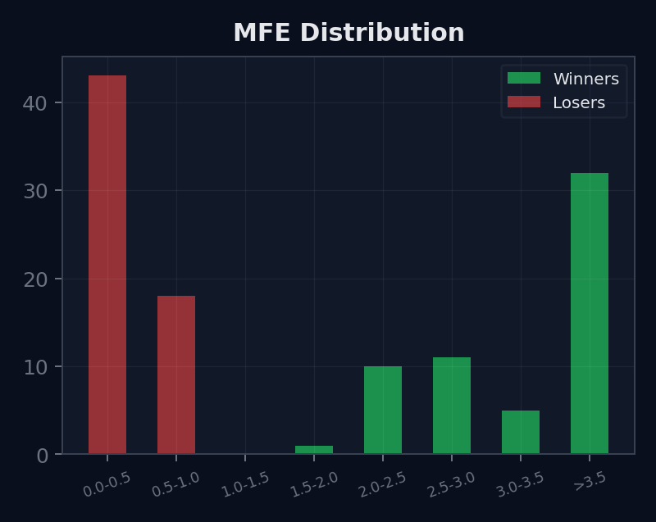
How far trades go in your favor. Losers with high MFE = management problem.
Property | Specification
Chart type | Stacked bar chart
Buckets | 0–0.5R, 0.5–1.0R, 1.0–1.5R, 1.5–2.0R, 2.0–2.5R, 2.5–3.0R, >3.0R
Green / Red | Same stacking as MAE
Data | mfe_r for each trade
Key insight | Losers with MFE > 1R = trades that were winning before reversing

4.3 During vs Total MFE Scatter
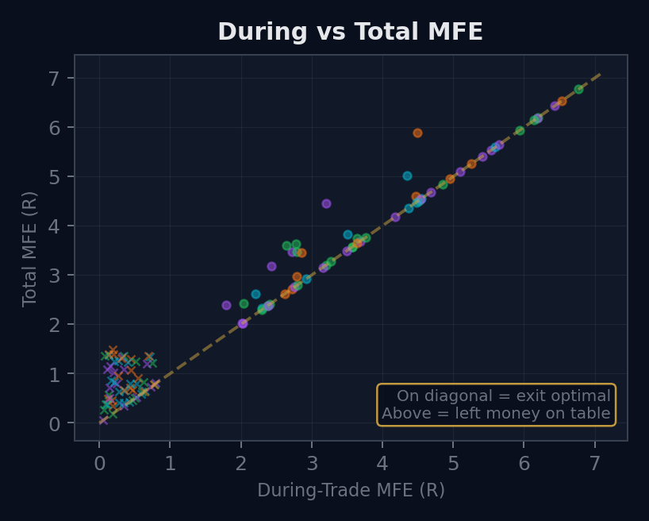
Each dot is a trade. Above the diagonal = money left on the table after exit.
Property | Specification
Chart type | Scatter plot
X-axis | During-trade MFE (mfe_r)
Y-axis | Total MFE including post-exit (total_mfe_r)
Dot color | By pair (using pair accent colors) or by win/loss
Dot shape | Circle for winners, X for losers
Diagonal line | Dashed gold, Y = X. On diagonal = exit captured full move.
Interaction | Hover shows trade #, pair, both MFE values, actual RR

5. Deep Analysis Charts
5.1 Trade Path Cloud
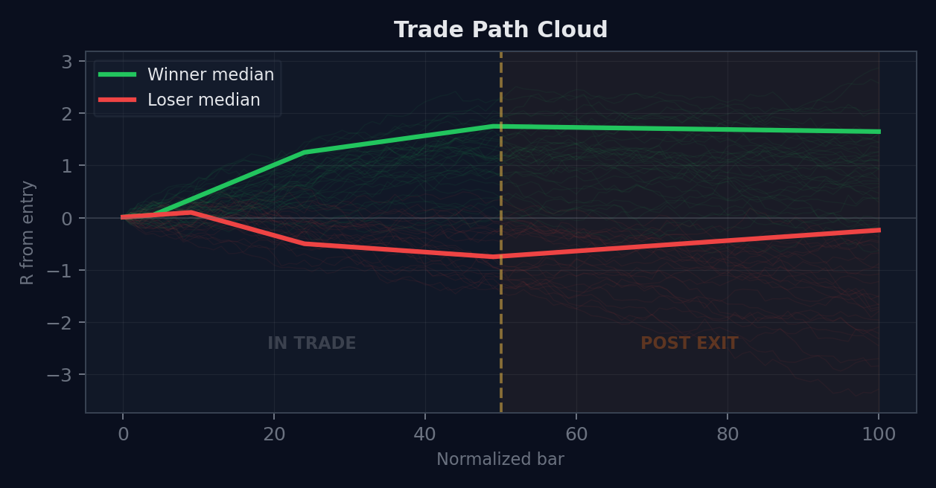
All trades overlaid. Thin lines = individual trades. Thick = median. Shaded = 25th–75th percentile.
Property | Specification
Chart type | Multi-line overlay with median and percentile bands
X-axis | Normalized bars: 0–50 = during trade (resampled), 50–100 = post-exit (actual bars)
Y-axis | R-multiple from entry
Thin lines | One per trade. Green (alpha 0.07) for winners, red (alpha 0.10) for losers.
Thick lines | Median path for winners (green) and losers (red)
Shaded bands | 25th–75th percentile fill for each group
Exit marker | Dashed gold vertical line at bar 50
Post-exit zone | Faint orange background tint for bars 50–100
Path normalization | Resample bar_close_r to 50 points via linear interpolation. Append post-exit portion.

5.2 Box Plots at Key Moments
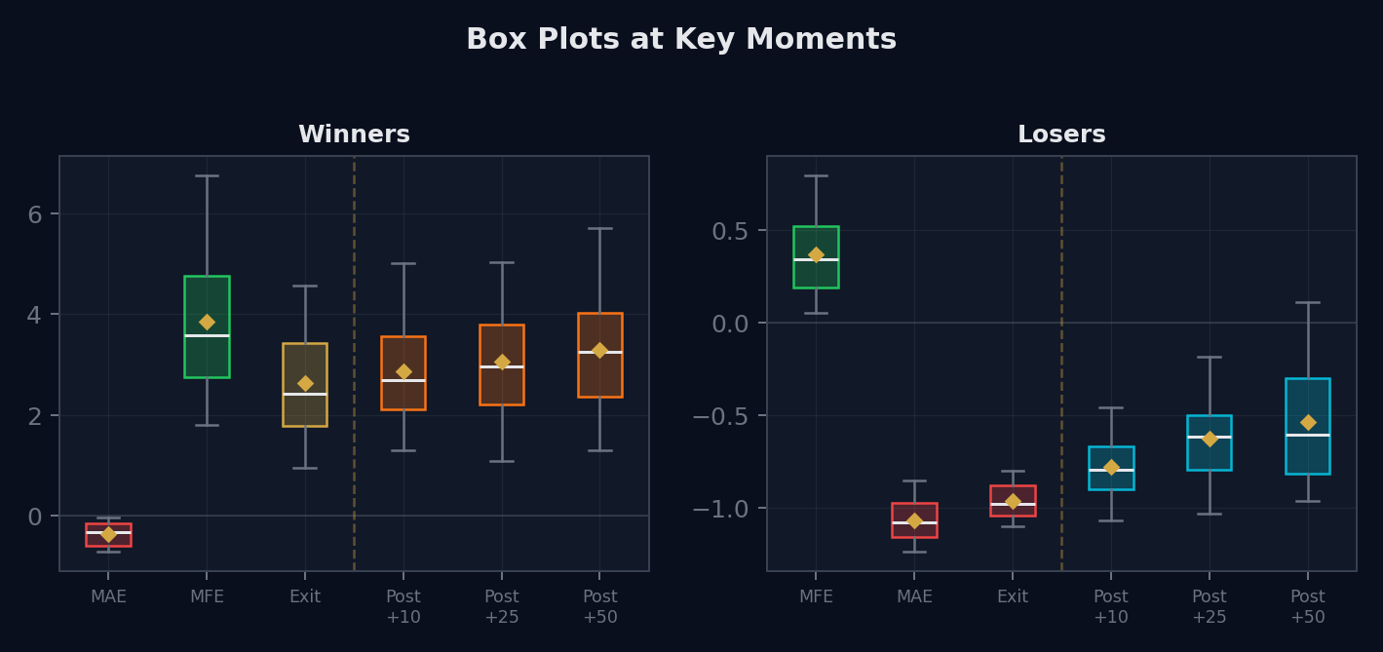
Left: winners. Right: losers. Six stages from MAE through post-exit checkpoints.
Property | Specification
Chart type | Two side-by-side box plot charts
Stages (winners) | MAE (red), MFE (green), Exit (gold), Post+10 (orange), Post+25 (orange), Post+50 (orange)
Stages (losers) | MFE (green), MAE (red), Exit (red), Post+10 (cyan), Post+25 (cyan), Post+50 (cyan)
Box | 25th–75th percentile. Whiskers = range excluding outliers.
Diamond | Mean value
Divider | Dashed gold vertical line between exit and post-exit stages
Winner MAE data | Collect −mae_r from each winner
Winner Post+N data | For each winner: max R-value in bar_close_r from exit index to exit+N
Loser Post+N data | Same, for losers. Cyan boxes rising above 0R = recovery.

5.3 Setup Comparison
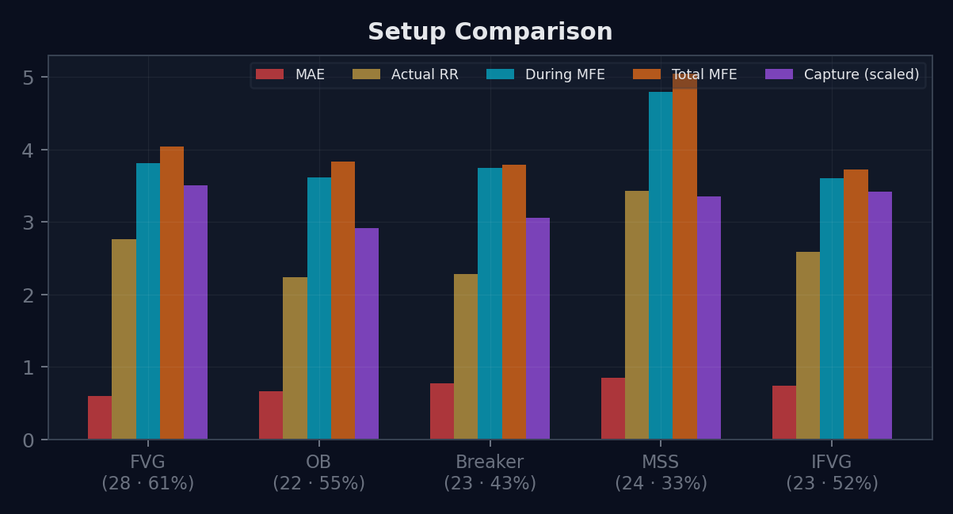
Full excursion profile per setup type. Five bars per setup.
Property | Specification
Chart type | Grouped bar chart, one cluster per setup
Bars per setup | MAE (red), Actual RR (gold), During MFE (cyan), Total MFE (orange), Capture % scaled (purple)
X-axis labels | Setup name, trade count, win rate, capture %
Capture scaling | capture_pct / 100 × max(total_mfe across setups) to fit the R-multiple Y-axis
Data | Each metric is the mean for winners of that setup (MAE uses all trades)

5.4 Losers Recovery Rate
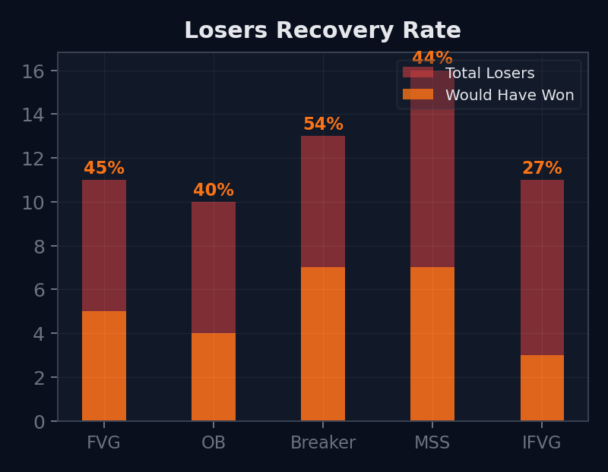
Per-setup: how many losers would have recovered within the post-exit window.
Property | Specification
Chart type | Bar chart with overlay
Red bar (back) | Total losers for that setup
Orange bar (front) | Losers where would_have_won = true
% label | recovery count / total losers × 100, displayed above each bar
Data | would_have_won: true if post_mfe_from_entry_r ≥ planned_rr × 0.5
Key insight | High % = stop too tight for this setup

6. What-If Simulator Section
6.1 Expectancy Heatmap
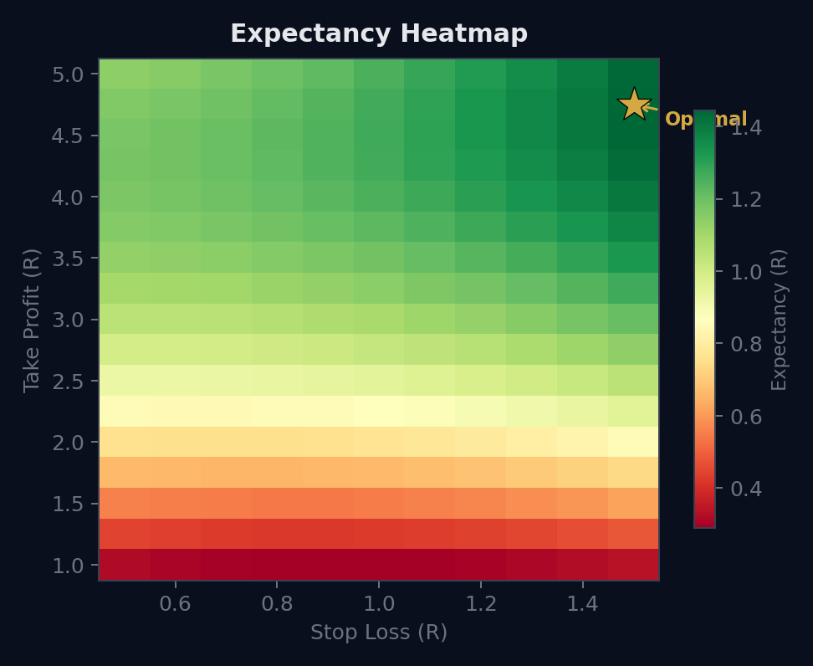
Every TP/SL combination tested. Green = profitable. Star = optimal. Red = losing.
Property | Specification
Chart type | 2D heatmap (color grid)
X-axis | Stop Loss in R: 0.5 to 1.5 in 0.1 steps (11 values)
Y-axis | Take Profit in R: 1.0 to 5.0 in 0.25 steps (17 values)
Cell value | Simulated expectancy: (sim_win_rate × tp) + (sim_loss_rate × -sl) adjusted for costs
Color scale | Red (negative) → Yellow (near zero) → Green (positive)
Optimal marker | Gold star on the cell with highest expectancy
Replay method | For each TP/SL combo: walk bar_high_r and bar_low_r for each trade. Check SL first, then TP.
Per-setup filter | Dropdown to run heatmap on one setup type only
Per-pair filter | Respects the global pair filter

6.2 Simulated vs Actual Equity
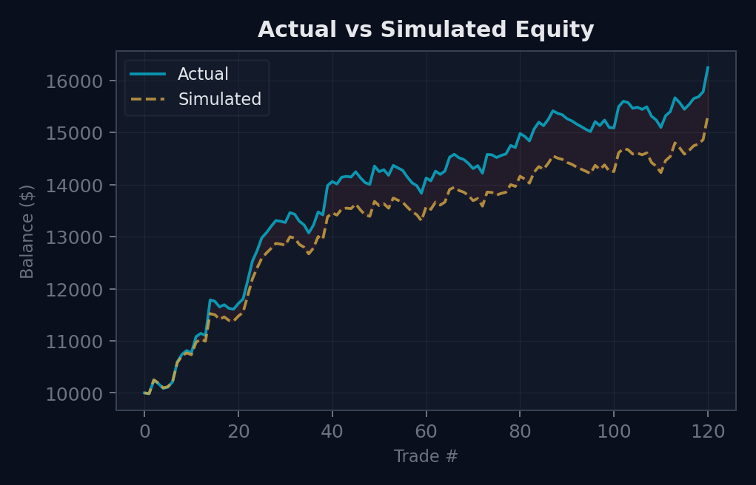
The dollar impact of changing TP/SL. Solid = actual. Dashed = simulated.
Property | Specification
Chart type | Dual line chart
Solid line (cyan) | Actual equity curve from the session
Dashed line (gold) | Simulated equity curve using the new TP/SL from the sliders
Shaded gap | Green if simulated > actual, red if simulated < actual
X-axis | Trade # (chronological)
Y-axis | Balance ($)
Updates | Recalculates when user moves TP/SL sliders or heatmap selection changes

6.3 Interactive TP/SL Optimizer (Excursion Bars)
This is the interactive version of the optimization. It combines the stacked excursion bars concept with the movable lines for real-time what-if exploration.

Property | Specification
Chart type | Vertical bars stacked side by side, one per trade, with movable horizontal lines
X-axis | Trade number (1, 2, 3... up to ~60 visible, scrollable)
Y-axis | R-multiples from entry. 0 = entry line.
Bar (above 0) | Extends from 0 to MFE (solid green). Extends further to total MFE (faded orange).
Bar (below 0) | Extends from 0 down to MAE (solid red).
Exit marker | A horizontal dot or dash on each bar at the actual exit R-multiple
Gold movable line | Horizontal, draggable. Represents the simulated TP level. Default at planned TP.
Red movable line | Horizontal, draggable below 0. Represents the simulated SL level. Default at -1R.
Real-time stats panel | As either line is dragged, updates: Win Rate, Avg Winner (R), Avg Loser (R), Expectancy (R), Profit Factor, Dollar PnL impact
Trade highlighting | When a trade flips outcome due to the new levels (winner becomes loser or vice versa), the bar flashes or changes color to indicate the change
Replay method | Uses bar_high_r and bar_low_r arrays (same as heatmap). Accurate intra-bar simulation.
Sorting | Sort bars by: chronological, MFE descending, MAE ascending, actual RR

How the Movable Lines Work
When the user drags the gold TP line to 2.5R:
For each trade, replay bar_high_r[]: did any bar reach 2.5R?
If yes AND no bar hit the SL line first: trade is a winner at 2.5R.
If the SL line is hit first: trade is a loser at the SL level.
If neither is hit: trade is inconclusive (grayed out).
When the user drags the red SL line to -0.7R:
Same replay but checking bar_low_r[] against -0.7R.
BOTH lines are evaluated together on every drag. The stats panel reflects the combined effect.
This is the same replay engine as the heatmap — just with a visual, interactive interface instead of a grid.

7. Planned vs Actual Section
A statistics panel (not a chart) showing discipline metrics. Two columns side by side.

Left Column: Discipline Metrics
Metric | Data Source
TP Modification Rate | Trades with TP changes / total × 100
SL Modification Rate | Trades with SL changes / total × 100
Avg Planned RR | Mean of planned_rr
Avg Actual RR (Net) | Mean of actual_rr_net for winners
Discipline Gap | Avg planned_rr − avg actual_rr_net
Avg Risk per Trade | Mean of planned_risk_pct

Right Column: Advanced Management Stats
Metric | Data Source
Multi-Entry Trades | Count with num_entries > 1 / total
All Entries Filled | Count where all entries filled / multi-entry count
Multi-TP Trades | Count with num_tps > 1 / total
BE Triggered | Count where be_triggered = true / count where be_enabled = true
Stopped at BE | Count where exited at breakeven / BE triggered count
Trail Activated | Count where trail_activated = true / count where trail_enabled = true

8. Post-Exit MFE by Setup

Separate from the aggregate post-exit curve. This shows one colored line per setup type, for winners only.
Property | Specification
Chart type | Multi-line chart, one line per setup
X-axis | Bars after exit (0–50)
Y-axis | Average additional MFE in R from exit
Colors | FVG = green, OB = cyan, Breaker = orange, MSS = purple, IFVG = gold
Key insight | Steepest curve = hold longer on that setup. Flattest = TP already optimal.
Data | For each setup, filter winners, compute post-exit MFE at each bar checkpoint

9. Data Requirements Summary
This is the complete list of data fields the dashboard reads. If a field is missing, the affected charts will not render correctly.

9.1 Per-Trade Fields Used by Dashboard
Field | Used By
actual_rr_gross, actual_rr_net | Stat cards, what-if bars, setup comparison, scatter
mfe_r | Stat cards, what-if bars, scatter, setup comparison, MFE distribution, path cloud
mae_r | Stat cards, MAE distribution, setup comparison, box plots
total_mfe_r | What-if bars, scatter, capture ratio, setup comparison
capture_ratio | Stat cards, capture histogram, setup comparison, instrument table
pnl_dollars_net | Session stats, equity curve, instrument table, simulated equity
commission_total | Session stats, instrument table
planned_rr | Planned vs actual section
would_have_won | Recovery rate chart, stat cards
bar_close_r[] | Path cloud (visualization)
bar_high_r[] | What-if simulator, heatmap, interactive optimizer
bar_low_r[] | What-if simulator, heatmap, interactive optimizer
setup_tag | Setup comparison, post-exit by setup, recovery rate, all filters
pair / ticker | Instrument table, pair filter, equity curve coloring
be_triggered, trail_activated | Advanced management stats
sl_tp_modifications[] | Planned vs actual modification rates
partial_exits[] | Blended RR calculation, scaling analytics
post_checkpoints[] | Box plots post-exit stages

9.2 Per-Session Fields Used by Dashboard
Field | Used By
starting_balance | Session stat cards, equity curve baseline
current_balance | Session stat cards
equity_curve[] | Equity curve chart, simulated equity comparison
max_drawdown_dollars, max_drawdown_pct | Session stat cards
instruments{} | Instrument breakdown table, pair filter options
leverage | Display in session info

The Minimum Viable Dashboard
If you need to ship a first version quickly, the minimum viable dashboard needs:
1. Session stat cards (balance, PnL, win rate, profit factor) — uses only scalar trade fields.
2. Equity curve — uses only equity_curve[] array.
3. MAE and MFE distributions — uses only mae_r and mfe_r per trade.
4. What-if bars — uses actual_rr, mfe_r, total_mfe_r.
5. Capture ratio histogram — uses capture_ratio.
These 5 elements give 80% of the analytical value. Add the path cloud, box plots, heatmap, and interactive optimizer in phase 2. They require the three arrays per trade (bar_close_r, bar_high_r, bar_low_r) which are the most storage-intensive fields.

